Name: Muhammad Shahzaib
Roll No: FALL-23-BSCS-251
Section: G
Subject: Web Technologies LAB



Department of Computer Science

Lab 2: Setting up the Web Development Environment

Lab 2: HTTP, URLs and Request/Response Basics

Objectives
- Understand how HTTP works by observing request/response cycles.
- Use browser DevTools and Postman/curl to inspect headers and status codes.
- Simulate caching and status code behavior.

Tools Required
- Browser DevTools (Chrome, Firefox, Edge)
- Postman or curl (command-line tool)
- Live Server (VS Code extension or any static server)

Step-by-Step Tasks

Step 1: Inspect HTTP Requests with DevTools
- Open any simple HTML page (e.g., index.html) using Live Server.
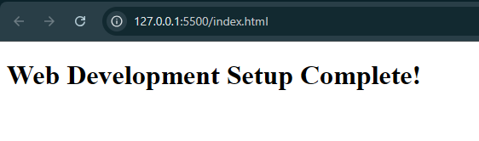
- Right-click → Inspect → go to Network tab.
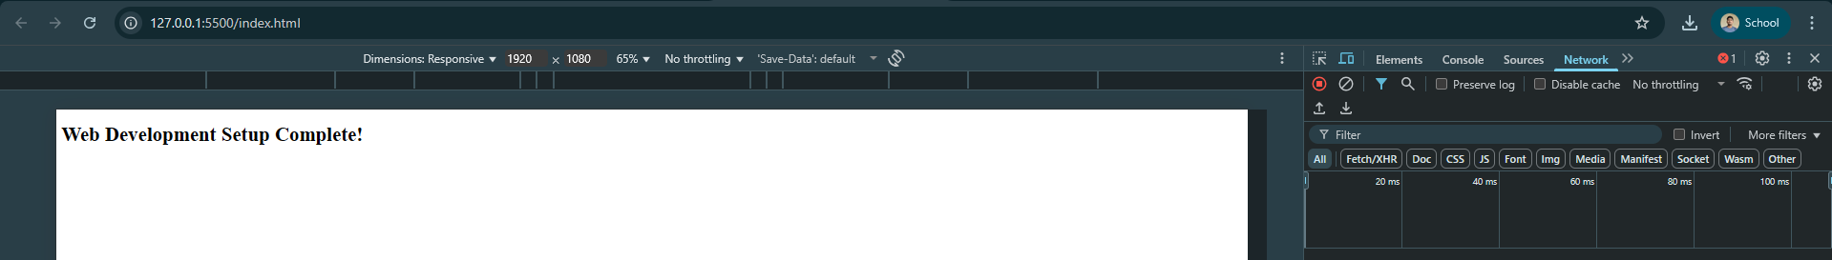
- Reload the page (F5) to capture network activity.
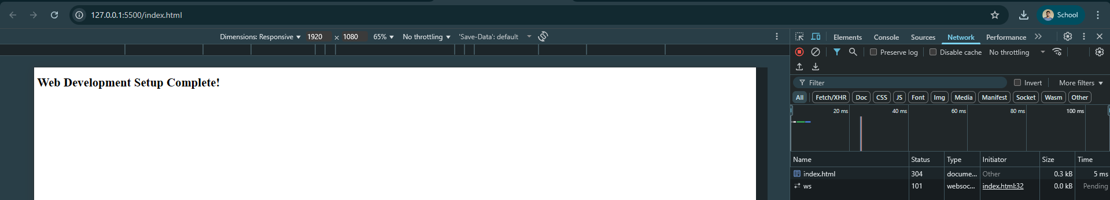

- Click on the main request (e.g., index.html) and observe:
- Request Method (GET)
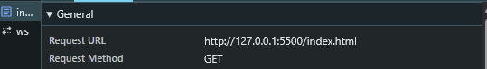
- Status Code (e.g., 200 OK)
- Request Headers (Host, User-Agent)
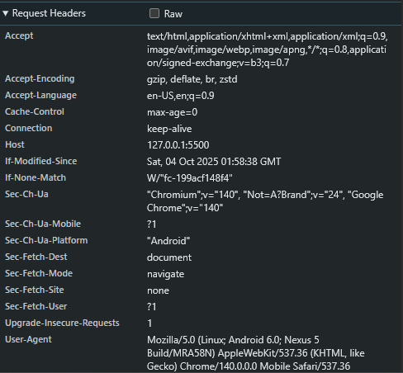
- Response Headers (Content-Type, Cache-Control)
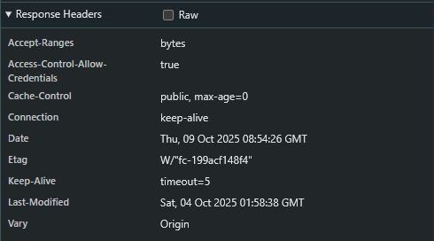

Screenshot Tip: Capture the headers and status code view.

Step 2: Make GET/POST Requests with Postman or curl
Using Postman
- Open Postman and create a GET request to your local server (e.g., http://localhost:5500/index.html).
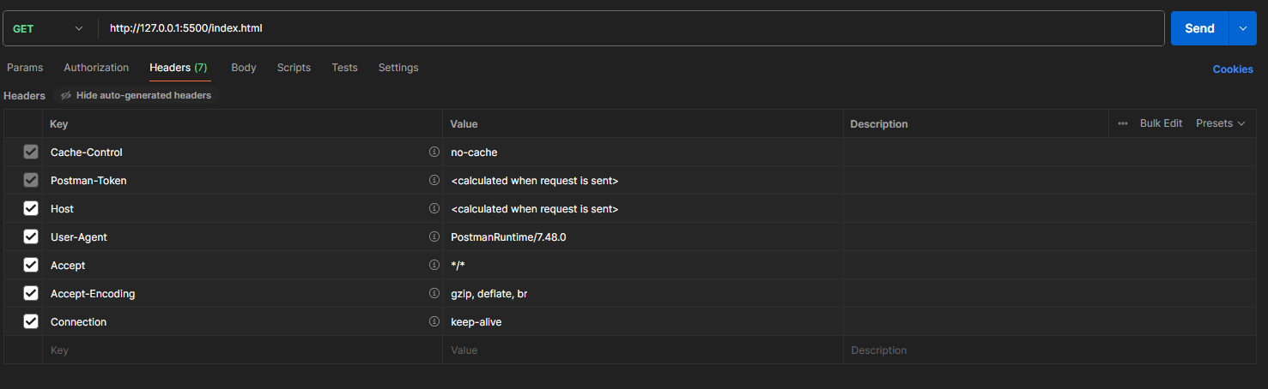
- Observe the status code, response body, and headers.
- Create a POST request to a test endpoint (e.g., https://httpbin.org/post).
  - Add a JSON body:
  - {
  - "name": "Student",
  - "lab": "HTTP Basics" o } o Send the request and inspect the response.
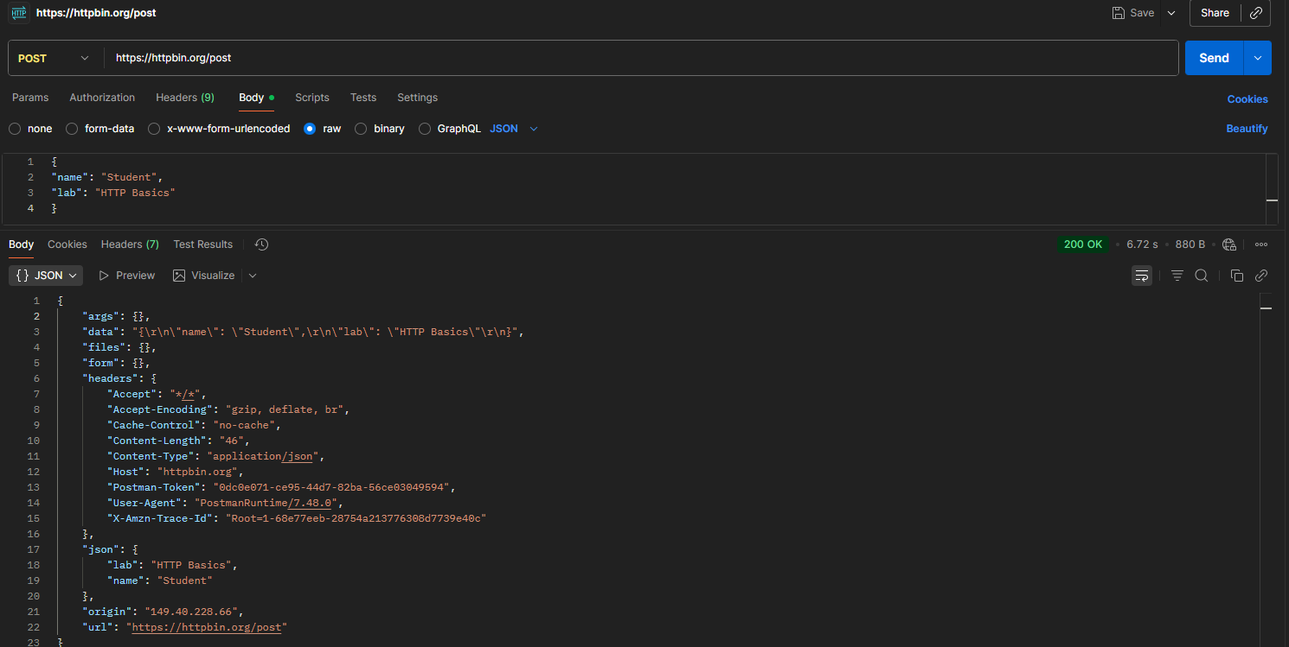

Using curl (optional)
curl -X POST https://httpbin.org/post -H "Content-Type: application/json" -d '{"name":"Student","lab":"HTTP Basics"}'
Screenshot Tip: Capture one GET and one POST request with headers and status.

Step 3: Simulate Caching and Status Codes
Modify HTML to simulate caching
- Add meta tags to your HTML <head>:
<meta http-equiv="Cache-Control" content="no-cache, no-store, mustrevalidate">
<meta http-equiv="Pragma" content="no-cache">
<meta http-equiv="Expires" content="0">
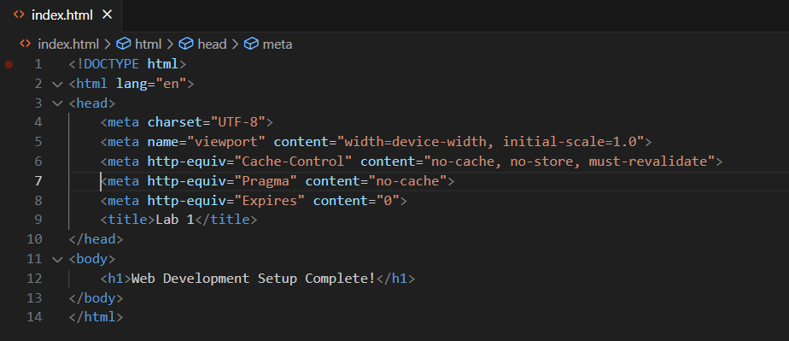
After adding the metatags in the index.html file.

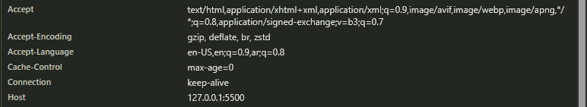

- Reload the page and observe changes in response headers. Simulate Status Codes Use these test URLs:
- 200 OK: https://httpbin.org/status/200
- 301 Redirect: https://httpbin.org/status/301
- 404 Not Found: https://httpbin.org/status/404
Screenshot Tip: Capture each status code response in DevTools or Postman.

Deliverables
Create a Markdown file or short report with:

Required Sections
- Screenshots of:
  - DevTools request inspection o One GET and one POST request (Postman or curl) o Status code simulations (2xx, 3xx, 4xx)
- Explanations:
  - Identify parts of request/response (method, headers, status)
  - Describe what caching headers do o Explain the meaning of each status code

CONCLUSION:
________________________________________________________
________________________________________________________
________________________________________________________
________________________________________________________

RUBRICS:

Performance |  |  | Lab Report
Description | Total  Marks | Marks Obtained | Description | Total  Marks | Marks Obtained
Ability to  Conduct practical | 5 |  | Structure | 5
Data Analysis & Interpretation | 5 |  | Efficiency | 5
Total Marks obtained |  |  | Total Marks Obtained

Instructor Signature

